**Descriptions of Divvy Data Set**

The data set shows 300 stations and 2953 bicycles and also it contains twelve variables. They are shown below with respective types.

trip_id: integer

starttime: date  
stoptime: date  
bikeid: integer

tripduration: integer/sec  
from_station_name: string  
from_station_id: integer  
to_station_id: integer

to_station_name: string

usertype: string

gender: string

birthyear: integer

As it is possible to notice, in this data set there are 2 types of users: customer and subscriber, the Figure 2 presents the quantity of each one. 34,67% are customers and 65,33% are subscribers. For subscribers, gender and birth of year are present. The gender is shown in Figure 1.

C:\Users\Elaine e Cristiano\Desktop\gender.PNG C:\Users\Elaine e Cristiano\Desktop\usertype.PNG 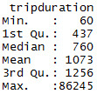

Figure 1 – Gender Figure 2- User type Figure 3 - Trip duration

Modifications blabla

1. For each station, get the average trip duration where it is the start

a$from_station_id a$tripduration

1 5 1022.6797

2 13 746.7389

3 14 961.7960

4 15 938.7343

5 16 1000.2398

6 17 1006.9787

7 19 873.6544

8 20 871.9290

9 21 766.0633

10 22 834.6203

11 23 947.1692

12 24 1141.7943

13 25 1407.0917

14 26 1343.2269

15 27 1090.9013

16 28 797.7472

17 29 973.8135

18 30 908.0371

19 31 847.5990

20 32 679.8053

21 33 956.0980

22 34 1518.4240

23 35 1666.3277

24 36 902.9017

25 37 888.3610

26 42 1197.7362

27 43 1248.8706

28 44 1062.4758

29 45 1442.1640

30 46 868.7859

31 47 937.8097

32 48 754.9310

33 49 759.3658

34 50 798.6226

35 51 801.3149

36 52 1083.7943

37 53 816.0249

38 54 936.4982

39 55 905.4619

40 56 756.3582

41 57 899.1998

42 58 919.5626

43 59 1021.7125

44 60 1011.5921

45 61 977.4474

46 62 1576.9618

47 66 682.8548

48 67 735.9069

49 68 709.5588

50 69 962.8667

51 71 774.3603

52 72 969.7742

53 73 839.9102

54 74 799.1648

55 75 763.9108

56 76 1623.3777

57 77 729.0766

58 80 688.6149

59 81 832.5048

60 84 786.1109

61 85 1658.5134

62 86 988.6929

63 87 817.8158

64 88 777.3364

65 90 1614.1760

66 91 716.6646

67 92 899.1456

68 93 788.7335

69 94 1166.4101

70 97 1577.0389

71 98 745.8149

72 99 1470.7341

73 100 748.9177

74 106 1088.4757

75 108 806.7121

76 109 700.9566

77 110 967.5725

78 111 772.0602

79 112 959.8674

80 113 1039.1802

81 114 1043.6068

82 115 866.2843

83 116 952.8117

84 117 808.1974

85 118 949.9623

86 119 979.8977

87 120 1199.0931

88 121 2204.0256

89 122 985.8235

90 123 995.6876

91 124 1254.8306

92 126 1379.9659

93 127 1004.3390

94 128 1050.2835

95 129 878.8196

96 130 831.9995

97 131 978.1429

98 132 1208.4168

99 134 733.7303

100 135 1066.3888

101 136 1422.5759

102 137 853.8053

103 138 857.9096

104 140 1091.3395

105 141 1247.9316

106 143 1096.7172

107 144 1044.4715

108 146 880.9041

109 147 1787.5662

110 148 1150.6945

111 149 1696.7065

112 150 1835.1883

113 152 771.4525

114 153 758.5780

115 154 903.4907

116 156 992.2623

117 157 1393.8350

118 158 950.1305

119 159 804.3462

120 160 940.0243

121 162 1043.4287

122 163 980.1107

123 164 747.1501

124 165 1100.0252

125 166 900.0289

126 167 1835.1519

127 168 1067.8939

128 169 810.3011

129 170 810.7894

130 171 1078.7878

131 173 1273.2425

132 174 749.8718

133 175 797.1887

134 176 1061.7089

135 177 1456.1648

136 178 1126.2810

137 179 1555.0542

138 181 974.0936

139 183 1024.7431

140 184 2059.8608

141 185 1073.7906

142 186 851.4888

143 188 946.0329

144 190 779.3366

145 191 694.8372

146 192 775.1585

147 193 1511.7774

148 194 1212.5618

149 195 997.3576

150 196 1118.8240

151 197 1108.0626

152 198 874.8403

153 199 1067.7584

154 200 3086.4576

155 201 4942.2562

156 202 906.8393

157 203 1028.2395

158 204 2118.5881

159 205 842.1965

160 206 957.9604

161 207 998.9071

162 208 926.1562

163 209 835.0846

164 210 862.8730

165 211 1159.9624

166 212 864.9332

167 213 1034.9043

168 214 1033.4722

169 215 1178.4485

170 216 1278.7882

171 217 678.2201

172 218 1477.3021

173 219 1080.7775

174 220 1046.1593

175 222 1181.5088

176 223 981.0754

177 224 963.7315

178 225 954.3776

179 226 938.4937

180 227 1083.2159

181 228 1116.0742

182 229 891.5555

183 230 867.7342

184 231 1112.5162

185 232 1149.3560

186 233 658.5528

187 234 831.4692

188 236 1310.6651

189 237 1394.3547

190 238 920.9510

191 239 1539.9555

192 240 758.6365

193 241 758.6106

194 242 850.7646

195 243 1026.9033

196 244 941.5398

197 245 1121.5679

198 246 949.5915

199 247 2079.9703

200 248 1507.6614

201 249 1726.1256

202 250 927.1077

203 251 1493.5397

204 252 2140.6372

205 253 1164.8543

206 254 1146.4886

207 255 1318.0180

208 256 988.1517

209 257 1024.7381

210 258 1232.3876

211 259 1262.0736

212 260 1371.1214

213 261 817.7340

214 262 1864.4211

215 263 1953.4603

216 264 1071.1293

217 265 2172.1124

218 267 2563.5367

219 268 1389.0329

220 271 2025.1712

221 272 1478.3544

222 273 1135.8304

223 274 871.4652

224 275 658.6883

225 276 1109.3271

226 277 1133.1637

227 278 1918.9711

228 279 1737.1297

229 280 1201.2360

230 281 700.1124

231 282 921.5871

232 283 796.5167

233 284 1378.7287

234 285 1356.0288

235 286 839.8519

236 287 785.0104

237 288 959.5303

238 289 1008.7407

239 290 1100.1254

240 291 1043.6699

241 292 760.3369

242 293 1060.6550

243 294 2005.3674

244 295 1409.2990

245 296 1011.5217

246 297 907.9701

247 298 1088.3180

248 299 1056.8597

249 300 1071.0394

250 301 1060.9866

251 302 957.5918

252 303 1073.8796

253 304 947.0416

254 305 1114.5369

255 306 951.6907

256 307 947.4995

257 308 1167.6619

258 309 1029.9496

259 310 1047.2194

260 311 1015.9264

261 312 1216.0673

262 313 1329.4364

263 314 886.3212

264 315 1101.2000

265 316 834.1054

266 317 994.8165

267 318 757.4836

268 319 865.0100

269 320 823.3358

270 321 1165.6663

271 322 1696.6568

272 323 1564.3797

273 324 1460.1483

274 325 1147.7287

275 326 853.1829

276 327 912.5412

277 328 1076.8151

278 329 1430.3318

279 330 1078.1391

280 331 980.3868

281 332 929.5674

282 333 977.0128

283 334 1386.4279

284 335 763.2500

285 336 820.0811

286 337 1013.2378

287 338 1268.2219

288 339 1048.3953

289 340 1011.5454

290 341 1685.1074

291 342 809.3703

292 343 821.1611

293 344 698.0344

294 345 1717.4887

295 346 744.2719

296 347 888.1471

297 348 3799.0701

298 349 931.1455

299 350 926.9409

300 351 3194.4580

1. For each station, get the average trip duration where it is the end

a$to_station_id a$tripduration

1 5 975.7747

2 13 920.2771

3 14 966.7256

4 15 774.0947

5 16 1047.9893

6 17 865.0348

7 19 914.5284

8 20 808.0309

9 21 671.5878

10 22 846.8565

11 23 1018.0175

12 24 1262.8786

13 25 1389.1581

14 26 1281.5736

15 27 1051.3585

16 28 881.5664

17 29 973.0429

18 30 956.6729

19 31 789.9781

20 32 659.7971

21 33 1037.6295

22 34 1603.4861

23 35 1626.1011

24 36 867.4596

25 37 858.2073

26 42 1190.2194

27 43 1078.1709

28 44 950.4434

29 45 1512.9203

30 46 896.1996

31 47 867.3366

32 48 836.4523

33 49 751.5082

34 50 727.9198

35 51 758.6820

36 52 1026.4536

37 53 860.0810

38 54 921.8010

39 55 968.4474

40 56 833.4087

41 57 853.1894

42 58 839.6050

43 59 914.7588

44 60 961.8514

45 61 1032.5947

46 62 1601.1187

47 66 695.5587

48 67 740.9995

49 68 770.9560

50 69 900.9226

51 71 766.6318

52 72 1009.7186

53 73 774.7477

54 74 723.0986

55 75 758.5526

56 76 1609.6192

57 77 706.7757

58 80 725.2941

59 81 770.2559

60 84 763.1035

61 85 1693.9575

62 86 1031.6505

63 87 830.7067

64 88 776.0916

65 90 1484.9912

66 91 660.0054

67 92 928.7174

68 93 872.8034

69 94 1157.6955

70 97 1645.6126

71 98 725.3107

72 99 1432.9152

73 100 745.9981

74 106 1072.0611

75 108 788.7412

76 109 673.2720

77 110 894.2498

78 111 771.4078

79 112 817.8785

80 113 876.1287

81 114 1063.1578

82 115 811.9932

83 116 913.4784

84 117 806.5382

85 118 972.7254

86 119 1124.3153

87 120 1093.4775

88 121 1841.6743

89 122 1029.9414

90 123 1027.1224

91 124 1277.5630

92 126 1419.2742

93 127 992.0983

94 128 940.0920

95 129 1084.8757

96 130 806.8574

97 131 929.1261

98 132 1156.2624

99 134 711.2563

100 135 1009.1781

101 136 1513.0712

102 137 783.1915

103 138 812.2812

104 140 1017.6851

105 141 1253.1880

106 143 1149.1228

107 144 1013.7135

108 146 824.3873

109 147 1361.8451

110 148 1138.5679

111 149 1594.3185

112 150 1815.6455

113 152 894.0370

114 153 787.0332

115 154 980.1446

116 156 928.9020

117 157 1294.9000

118 158 1062.5713

119 159 1123.5911

120 160 1007.7831

121 162 1078.7792

122 163 1077.5804

123 164 770.6856

124 165 1084.5730

125 166 895.4598

126 167 1473.6330

127 168 1006.3289

128 169 857.2201

129 170 863.3588

130 171 1091.5920

131 173 1278.4988

132 174 627.3043

133 175 885.6928

134 176 1013.0069

135 177 1536.3249

136 178 1035.3283

137 179 1811.2887

138 181 881.0267

139 183 1028.2711

140 184 1882.4045

141 185 1052.5140

142 186 903.6856

143 188 791.8876

144 190 732.2055

145 191 820.4336

146 192 756.2088

147 193 1580.5992

148 194 1220.5580

149 195 1071.5460

150 196 1109.8898

151 197 1071.9278

152 198 734.3948

153 199 1105.6084

154 200 3487.8246

155 201 4871.0857

156 202 951.8305

157 203 1574.0675

158 204 3495.0262

159 205 876.8484

160 206 943.7880

161 207 1135.4413

162 208 1541.9459

163 209 838.8521

164 210 979.4760

165 211 1135.5203

166 212 844.8033

167 213 1116.3398

168 214 965.6807

169 215 1270.9163

170 216 1454.0541

171 217 665.6712

172 218 1401.3253

173 219 1046.7025

174 220 1011.2306

175 222 1201.2797

176 223 909.8288

177 224 976.7406

178 225 971.8903

179 226 943.1639

180 227 834.0453

181 228 1032.6906

182 229 852.2302

183 230 913.0386

184 231 1056.7028

185 232 1116.4833

186 233 587.1827

187 234 863.8076

188 236 1114.2576

189 237 1360.6708

190 238 841.8545

191 239 1630.2603

192 240 839.4439

193 241 673.9724

194 242 894.8621

195 243 957.0000

196 244 792.8009

197 245 1119.0627

198 246 752.7198

199 247 2289.2016

200 248 1402.5499

201 249 1732.9017

202 250 1007.5106

203 251 1711.5305

204 252 2838.9162

205 253 1293.8086

206 254 1113.7650

207 255 1391.1280

208 256 893.9833

209 257 1036.5924

210 258 1237.3111

211 259 1128.6413

212 260 1323.4757

213 261 887.0369

214 262 2268.2384

215 263 1909.6471

216 264 1036.4779

217 265 2222.1698

218 267 2156.7689

219 268 1544.8359

220 271 2888.1376

221 272 1189.5716

222 273 1112.2807

223 274 917.8486

224 275 780.9242

225 276 1163.9514

226 277 884.8764

227 278 1880.0030

228 279 1488.3257

229 280 1524.8411

230 281 1080.2091

231 282 804.2720

232 283 666.8655

233 284 1436.1424

234 285 1183.5290

235 286 883.0170

236 287 765.6528

237 288 1068.7137

238 289 991.3562

239 290 1131.9187

240 291 983.5006

241 292 841.0241

242 293 1314.4215

243 294 1948.4649

244 295 1382.2294

245 296 1071.3045

246 297 826.3394

247 298 1058.6881

248 299 992.4220

249 300 1087.4926

250 301 1104.8662

251 302 884.3154

252 303 1134.1000

253 304 965.7216

254 305 955.0382

255 306 884.2795

256 307 932.1308

257 308 1076.4349

258 309 1171.4109

259 310 1085.0584

260 311 1024.5732

261 312 1047.4244

262 313 1247.2245

263 314 843.9172

264 315 941.3990

265 316 909.1580

266 317 942.0768

267 318 738.7030

268 319 781.1692

269 320 694.5758

270 321 1090.3248

271 322 1894.1513

272 323 1658.7536

273 324 1282.2220

274 325 1214.0176

275 326 1157.3866

276 327 918.3916

277 328 1170.1280

278 329 1363.9054

279 330 1106.9017

280 331 972.1014

281 332 961.7897

282 333 1150.3534

283 334 1471.3167

284 335 974.3982

285 336 2028.4312

286 337 992.5021

287 338 1215.6982

288 339 1127.0041

289 340 1041.9247

290 341 1675.0036

291 342 876.7361

292 343 850.8787

293 344 714.9091

294 345 1640.2125

295 346 761.9417

296 347 765.8256

297 348 3552.0385

298 349 941.6517

299 350 1049.0112

300 351 3509.0095

1. For the members get the age and gender distribution

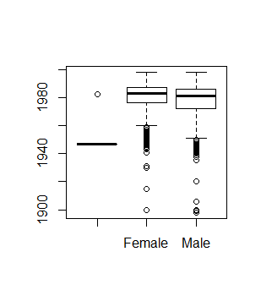

Figure 4 - Boxplot age x gender

Figure 4 shows a boxplot of gender and birthyear. Through this boxplot it is possible to see that the majority of subscribers has “about” born in 1940 or more and that are some outliers in the data who could not have more than 100 years old (e.g. 1900 ~ 1920). Subscribers can be male or female but there are 34 people that did not identified their gender as Figure 5 shows.

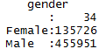

Figure 5 - Gender of Subscribers

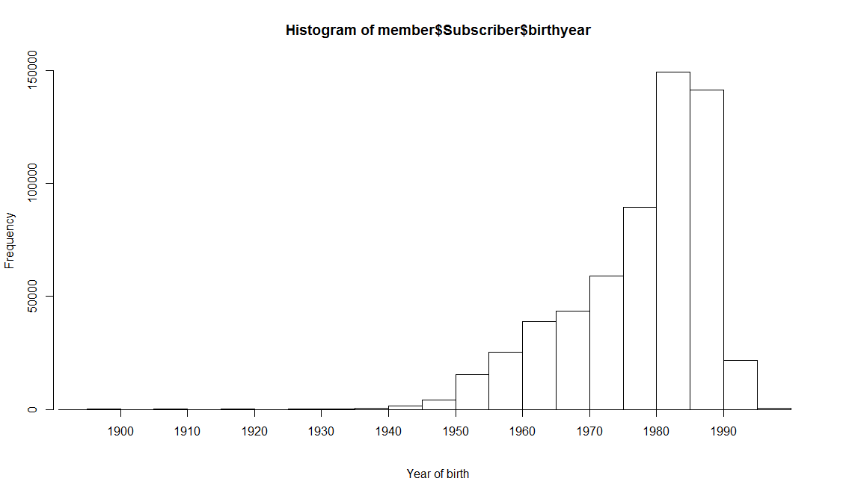

Figure 6 - Histogram of Year of birth

1. Get the trip duration distribution by age and by gender overall

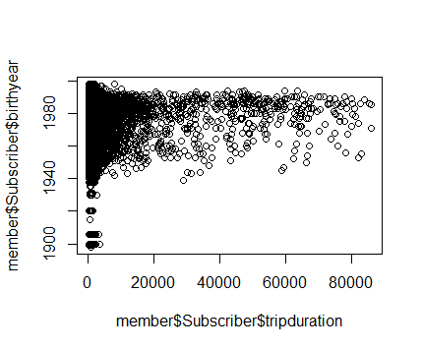

Figure 7 - Birth year X trip duration

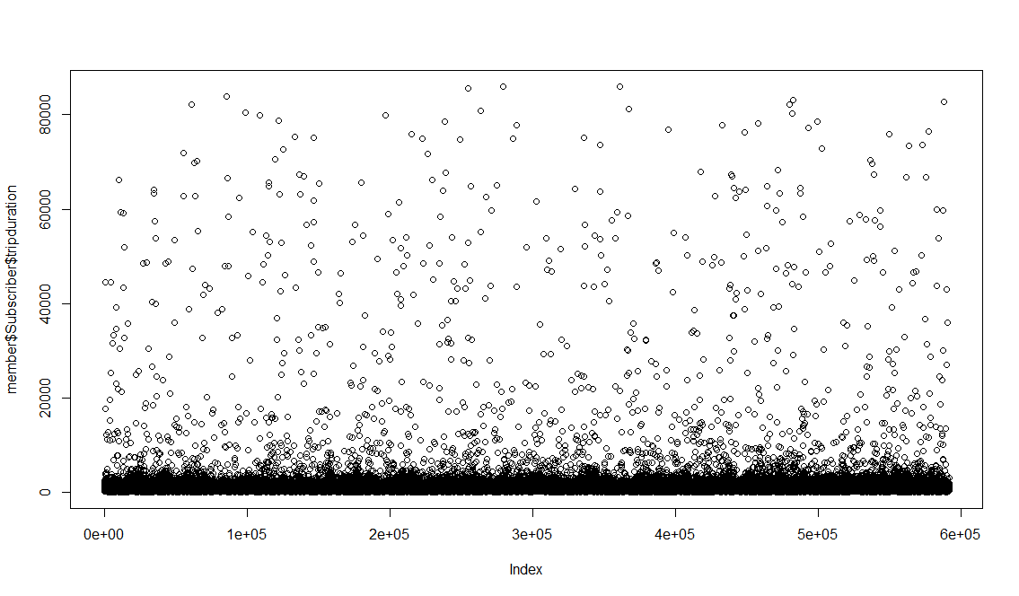

Figure 8 - Plot of trip duration overall

Figure 7 demonstrates that the majority of trip duration is less than 20000 seconds. There are people that maybe do not understand the rules of renting a bike through this service and they pass almost 24 hours (more than 80000 seconds) with the bike. The Figure 8 states this clearly. So, as we have seen majority of people who rent bikes are between 1940 and 2000 and the concentration of points in Figure 7 is more predominant above the year of 1940 confirming this perception.

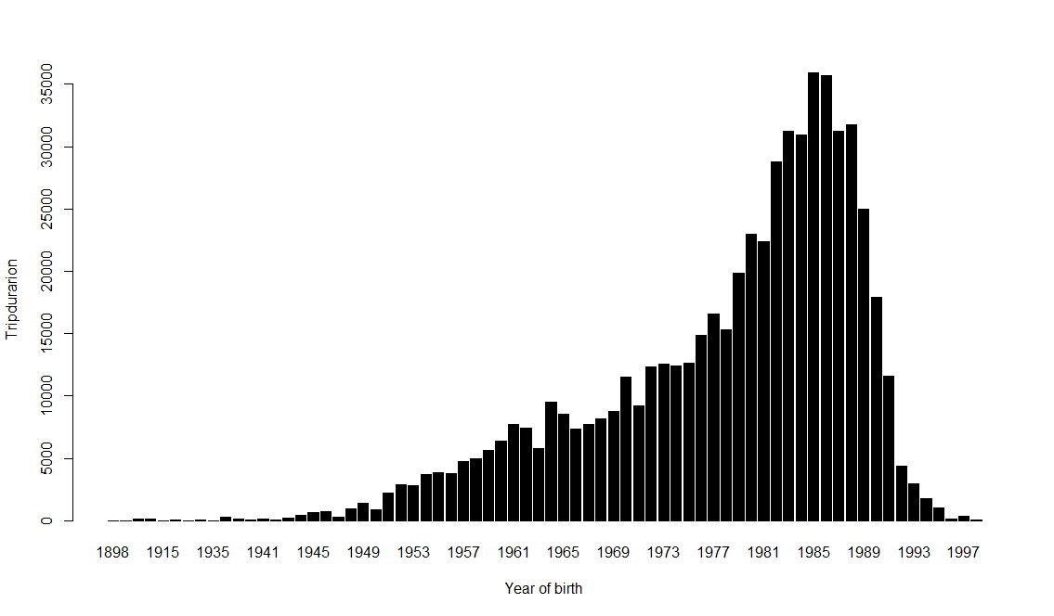

Figure 9 - Trip duration X Age

Figure 9 demonstrates what it is the age of the people who rides more on the bikes, we can conclude that people who are older ride less time than young people. People who born after 1981 and 1989 ride more.

*Figure 10* shows the distribution of people related to the trip duration. The majority of people ride around 200 and 450 seconds. A few people ride more than 1500.

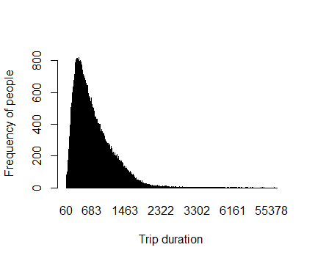

Figure 10 - People and trip duration

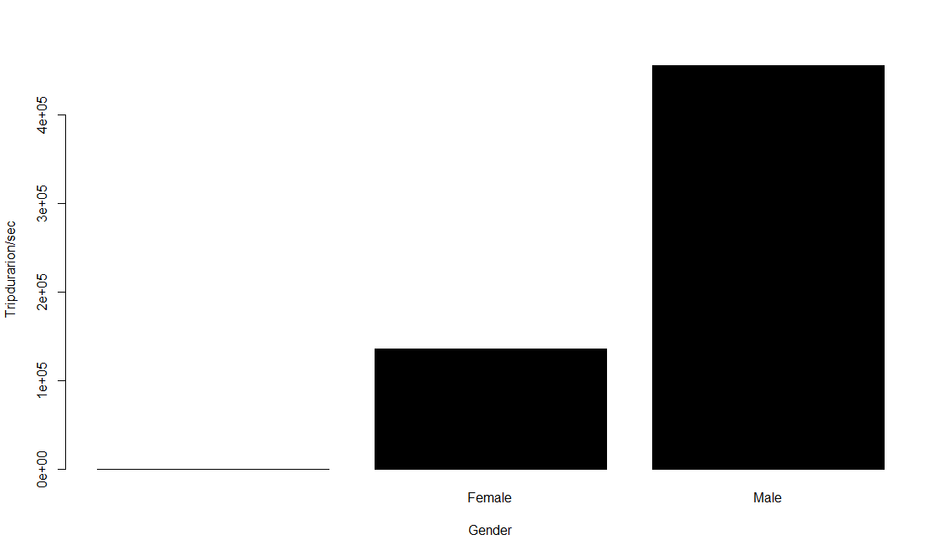

Figure - Gender and trip duration

In all data it is clear that men ride more than women. Figure 11 demonstrates this assumption again. And we can see that men pass more time riding than women.

1. For each station, get the distribution by age and by gender

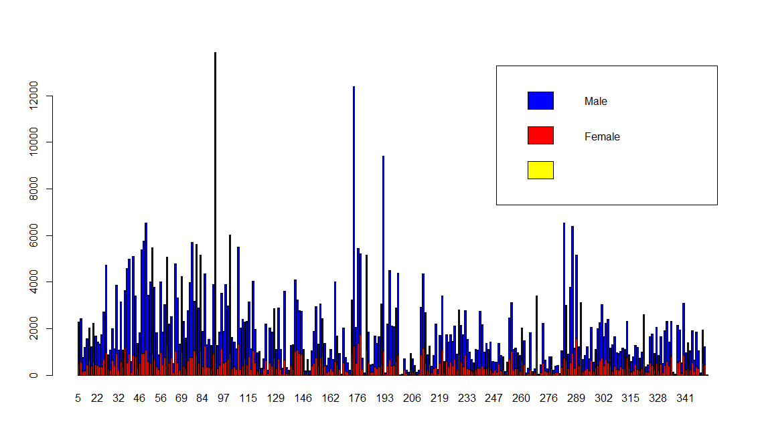

Figure - Distribution by gender in each station